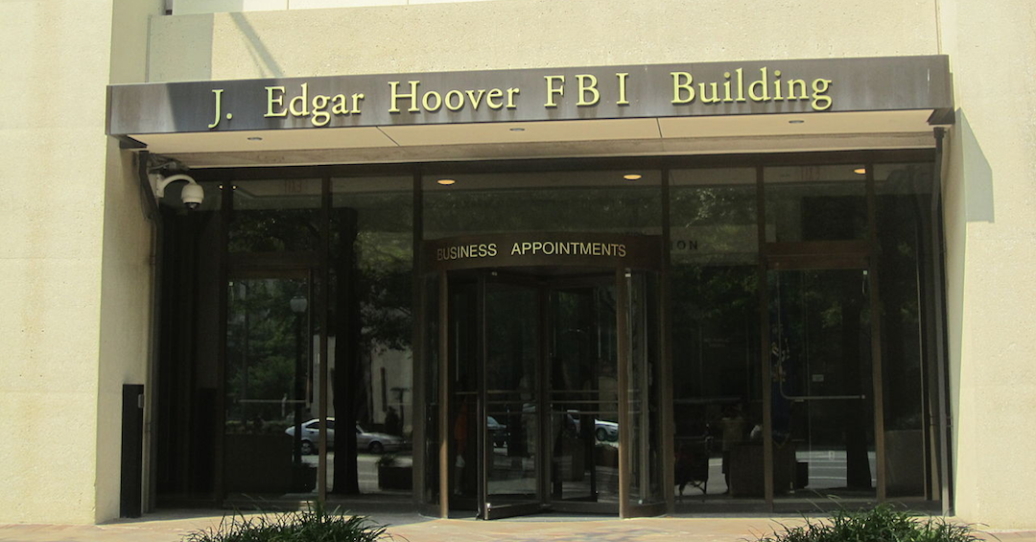

Excerpt from: https://caityjohnstone.medium.com/they-demolished-the-left-and-burned-the-blueprint-notes-from-the-edge-of-the-narrative-matrix-3163ac0dda69

They Demolished The Left And Burned The Blueprint: Notes From The Edge Of The Narrative Matrix

The empire’s information war against the left has been so successful that people don’t even know where “the left” is anymore. Most have it confused with things that are tangential like having pink hair and saying your pronouns, or outright right-wing like the Democratic Party.
Convincing everyone that communism is bad and unions work against your interests was just the first step. The next step was to confuse and muddy the waters of the political landscape so much that nobody even remembers where it was the left had been trying to get to — namely fighting and winning the class war that’s being waged upon the working class by the capitalist class, dismantling capitalism and imperialism, and creating a just and equitable society for everyone.
Now if you tell your average westerner to point to “the left”, they’ll point at “woke” hashtags and at political parties that are designed to support and protect the capitalist class. They didn’t just sabotage and destroy the left, they burnt the blueprints for how to rebuild it.
❖
The true left emphasizes the interests of marginalized communities with the goal of class solidarity. The fake left emphasizes the interests of marginalized communities with the goal of class division. You can sort out which is which by simple naked eye observation over time.
❖

